Module 7: Project Two

# **Analysis and Design**

Version 1.0

Ronny Z. Valtonen

**DriverPass**

**UML Use Case Diagram:**

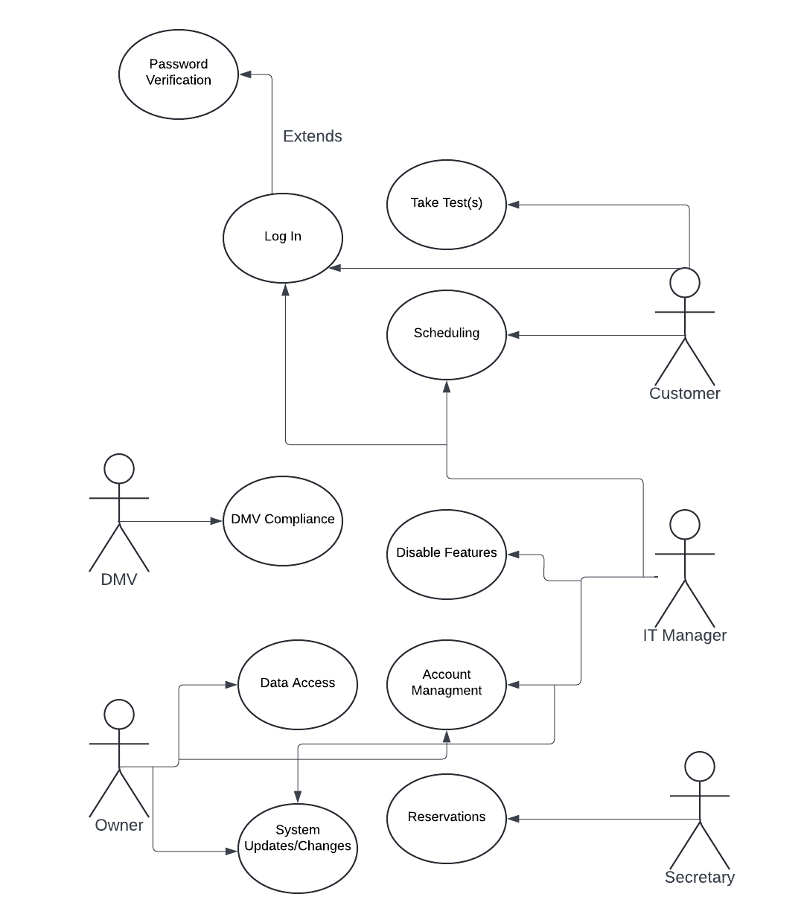

**Activity Diagram for Taking Tests:**

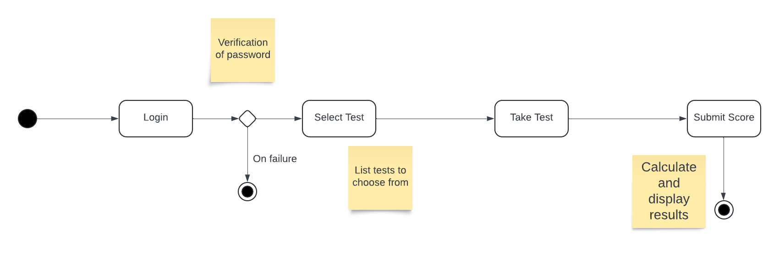

**Activity Diagram for making reservation:**

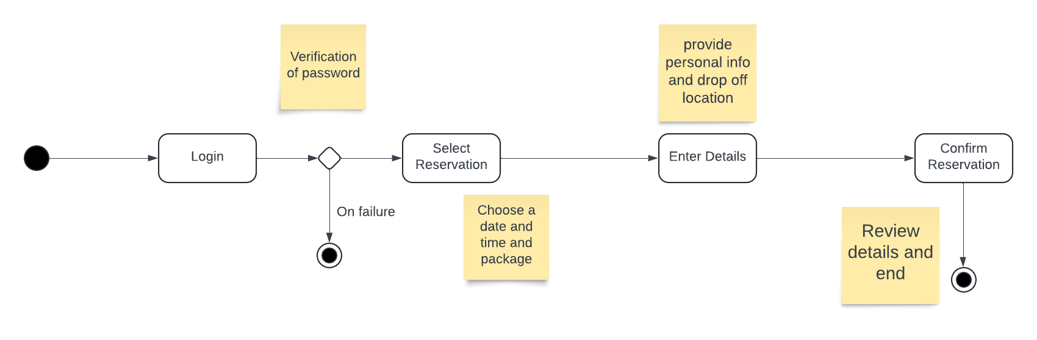

**Sequence Diagram for Taking Tests:**

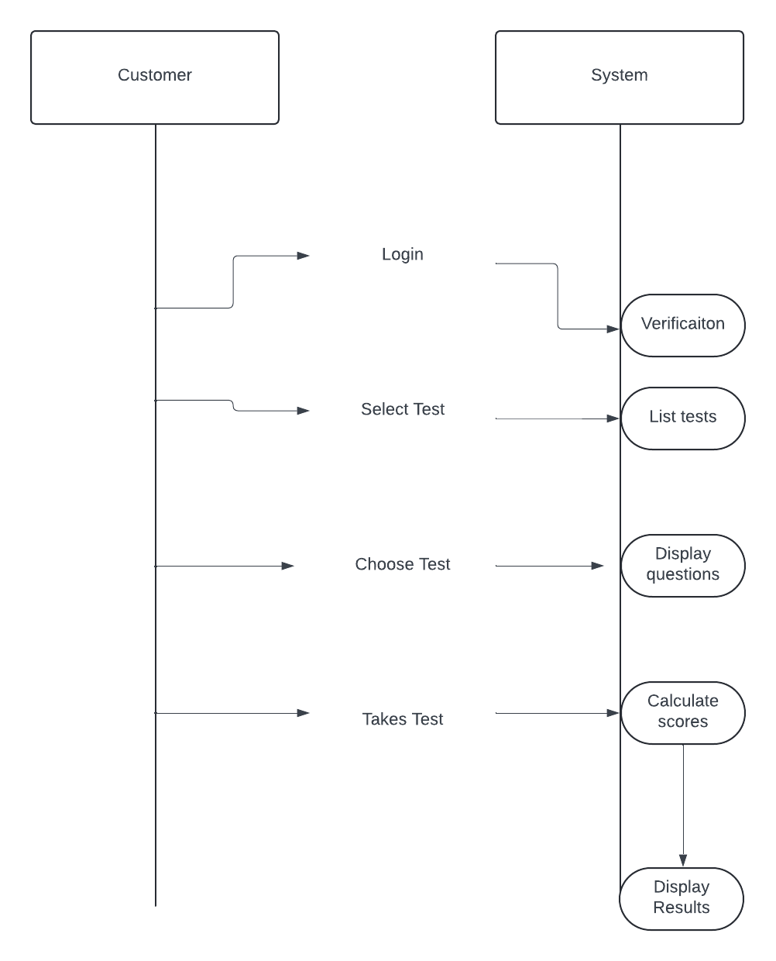

**UML Case Diagram**

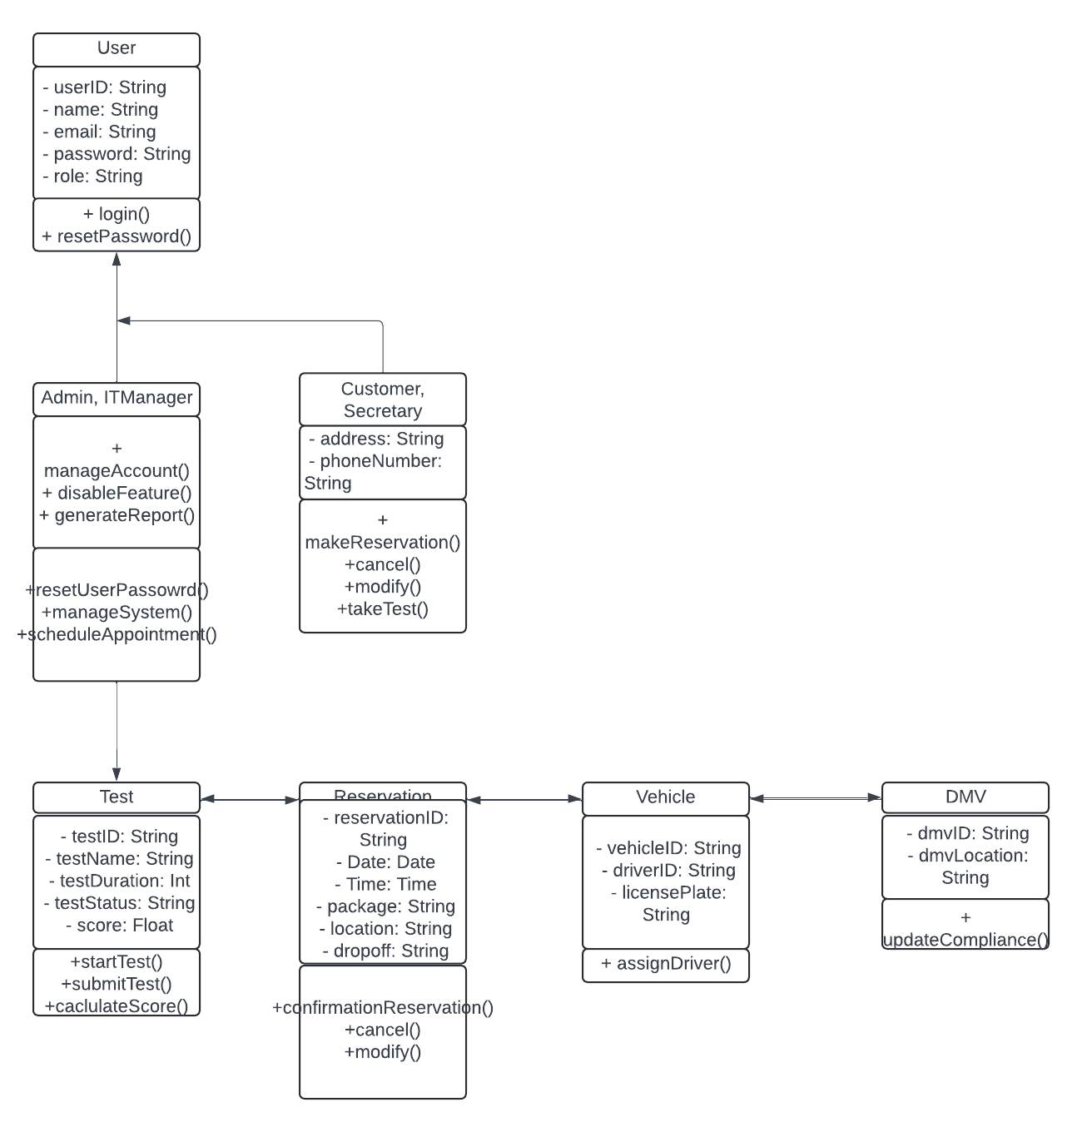

This system must have a server that processes the application, a server for the database / cloud and a backup server. The client also needs to have a computer system to handle the main operations as well as a secure network system. The servers shall run on a Linux OS due to the efficiency and the client systems shall run on a Windows OS due to the built in systems for handling security per user. The back end system shall be developed on Node.JS and the front end developed on React. The programming languages used should be JavaScript for frontend and Python for back end due to the ease of development. The cloud services shall be created on AWS for hosting and scaling the application. The system shall be integrated with the DMV system for compliance updates.